**Fire Alarm**

This design helps you to design your own fire alarm and prevent a major outbreak.

The circuit consists of a heat sensing IC which produces a voltage as output. The output of the IC is completely dependent upon the temperature and when a certain maximum temperature is exceeded the output produced is sufficient to turn a buzzer connected to the circuit on. Thus producing an alarm.

Components Required:

* 9V battery - 1
* Buzzer - 1
* Heat Sensor IC (LM35) - 1
* Breadboard - 1
* Connecting Wires - As required

Circuit diagram:

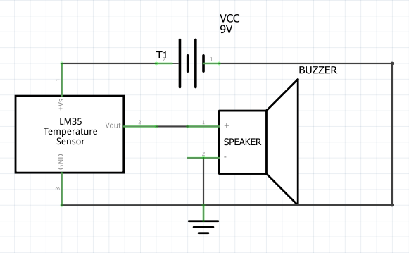

Procedure:

1. Identify the pins 1,2 and 3 on the LM-35 IC. Pin 1 will be the leftmost pin seen from the front view where the markings on the IC are also visible. Place pin 1 on A1 of the breadboard, then place pin 2 on A2 and finally pin 3 on A3.
2. Connect the positive terminal of the battery to E1 on the breadboard and negative of the battery to E3.

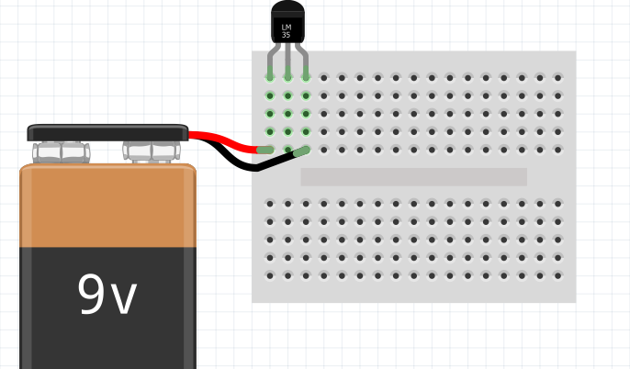

1. Next, connect the positive and negative terminals of the buzzer to pins A14 and A17 respectively. Note: longer pin of the buzzer will be positive.
2. Using a wire connect D14 and C2. Then using a different wire connect E17 and D3.
3. Test the circuit by heating the IC.

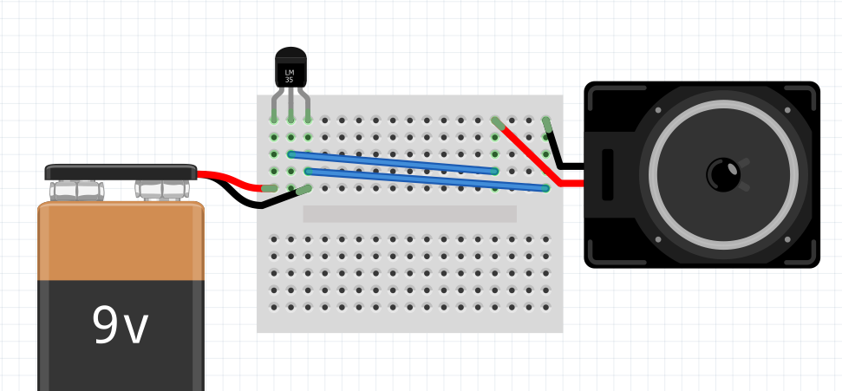

With that you have designed your own fire alarm. This simple circuit can be placed in places which are likely to catch fire and prevent a possible hazard.